**UAV Digital Twin을 위한 Generative AI기반 비행 동역학 Model 연구**장민석1*, 현정석1, 곽태호1, 곽찬1, Tuan Anh Nguyen1, 이재우1

건국대학교 항공우주설계인증연구소1

**Generative AI-based Flight Dynamic Model for UAV Digital Twin**

Minseok Jang1*, Jeongseok Hyun1, Taeho Kwag1, Chan Gwak1, Tuan Anh Nguyen1, Jae-woo Lee1

Konkuk Aerospace Design-Airworthiness Institute, Konkuk University, Seoul, South Korea1

━━━━━━━━━━━━━━━━━━━━━━━━━━━━━━━━

**Key Words**: Digital Twin(디지털 트윈), Generative AI(생성 AI), Data-Driven Modeling(데이터 기반 모델링)

Introduction

The digital twin is a technology that simulates real-world environments in the virtual environment to predict various situations. To achieve high levels of accuracy in simulations, researchers developed various environmental and vehicle models, including those for cars and aircraft. Notably, the high-precision simulation of vehicles relies on the use of mathematical models based on the 6DOF equation and various analytical methods such as AVL and CFD, which are utilized to construct a comprehensive database.

Recent studies have explored data-driven modeling techniques for predicting the dynamic state of Multicopter. However, these models struggle to predict results in untrained areas. To overcome this, this paper proposes using LSGAN to develop a data-driven model called Neural Dynamics. The model was compared to DNN-based models and flight test data, and it showed the potential to improve accuracy in predicting dynamic characteristics. This could lead to more reliable digital twin technology with various applications.

Neural Dynamics (LSGAN)

A GAN-based Neural Dynamics model was proposed for developing. Fig.1 is the structure of the LSGAN based model. The model utilizes a Generator to produce synthetic data and a Discriminator to differentiate between real and fake data. The Generator takes the input from velocity components, attitude values, and control signals, which are processed by the Hidden Layer to generate fake data that predicts velocity and attitude components. Table 1 is the structure of the Generator.

Fig. 1 Structure of Neural Dynamics (LSGAN)

Table 1 Detail Generator Structure of Neural Dynamics (LSGAN)

|  |  |
| --- | --- |
| **Parameter** | **Value** |
| **Input Layer Dimension** | **10** |
| **Hidden Layer Dimension** | **16** |
| **Number of Hidden Layer** | **5** |
| **output Layer Dimension** | **6** |
| **Learning rate** | **1e-6** |
| **Optimizer** | **ADAM** |
| **Mini-Batch Size** | **16** |

Dataset Construction

Neural Dynamics model trained using flight test data with different normalized ranges was evaluated by comparing the predicted data with the actual flight test data. The evaluation was conducted using flight test data in two different speed ranges: 7-10 m/s and 10-15 m/s. The dataset used for training the model consisted of 5 minutes of flight test data with the speed of the aircraft ranging from 0-3 m/s. The model was designed to predict the state of the aircraft with 250Hz, and for this purpose, the flight test data was divided into segments with 4000Hz. A mini-batch size of 16 was used to increase the learning rate.

To ensure accurate evaluation of the model, the speed components of the flight test data in the 10-15m/s and 7-10m/s ranges were normalized. The evaluation was carried out by comparing the predicted data generated by the Neural Dynamics model with the actual flight test data. The root mean squared error (RMSE) between the predicted and actual data was used as a metric to evaluate the performance of the model.

Neural Dynamics (LSGAN) Prediction

**Case 1) Normalized by 15 m/s.**

Fig. 2 shows that the LSGAN model outperformed the DNN model in predicting the flight test data, with fewer errors and less noise. Table 2 confirms this, with the LSGAN model demonstrating significantly smaller RMSE than the DNN model.

**Case 2) Normalized by 10 m/s.**

For flight data with speeds greater than 10m/s, predicting becomes difficult due to normalization range being exceeded. The LSGAN model shows better prediction performance for unlearned segment data than DNN. And Table 3 shows the LSGAN model demonstrating significantly smaller RMSE than the DNN model.

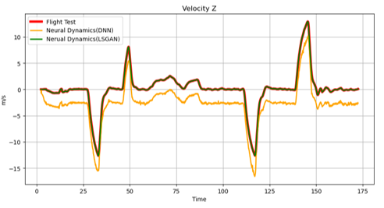

Fig. 2 Comparison of prediction data normalized by 15m/s (Flight Test, DNN, LSGAN)

Table 2 The accuracy of Neural Dynamics in $V_{z}$

|  |  |
| --- | --- |
| **Model** | **RMSE (m/s)** |
| **LSGAN** | **0.0055** |
| **DNN** | **2.6871** |

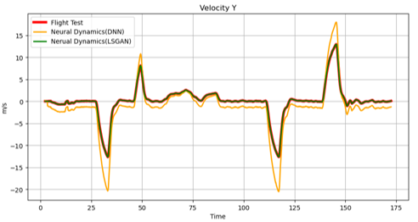

Fig. 3 Comparison of prediction data normalized by 10m/s (Flight Test, DNN, LSGAN)

Table 3 The accuracy of Neural Dynamics in $V_{y}$

|  |  |
| --- | --- |
| **Model** | **RMSE (m/s)** |
| **LSGAN** | **0.0061** |
| **DNN** | **2.2534** |

Conclusion

In this paper, LSGAN based Neural Dynamics are suggested for the high-precision Vehicle Dynamic model for UAV Digital Twin. The model demonstrated that when subjected to control inputs like those used in flight tests in untrained areas, the predicted state of the Neural Dynamics fell within the allowable range of prediction error with the flight test data.

Acknowledgement

This research was supported by Basic Science Research Program through the National Research Foundation of Korea (NRF) funded by the Ministry of

Education (No. 2020R1A6A1A03046811)**.** This work was funded and conducted under "the Seoul City Urban Air Transportation (UAM) Introduction Basic Plan Establishment Research Service" by the Seoul institute.

Reference

1) Jang, M., Hyun, J., Kwag, T., Gwak, C., Jeong, C., Nguyen, T.A., & Lee, J. (n.d.). Neural Dynamics for Multicopter Digital Twin using Deep Learning (pp. 804-805).: KSAS 2022 Fall Conference, The Korean Society for Aeronautical & Space Sciences.

2) Nguyen, T.A. Jeon, S.; Maw, A.A.; Min, D.; Lee, J.W. Toward dependable blockchain and AI engines of digital twin systems for urban air mobility. In Proceedings of the KSAS 2021 Spring Conference, The Korean Society for Aeronautical & Space Sciences, pp. 408–409.

3) Costa, J.; Matos, R.; Araujo, J.; Li, J.; Choi, E.; Nguyen, T.A.; Lee, J.-W.; Min, D. Software Aging Effects on Kubernetes in Container Orchestration Systems for Digital Twin Cloud Infrastructures of Urban Air Mobility. Drones 2023,7,35.https://doi.org/10.3390/drones7010035